**Geometry 1st Semester Final Exam Review** Name:_______________________________

G0, G1 Part 1, G1 Part 2, G2 Part 1, G2 Part 2, G3 Exam Date:____________________________

1. Match each term with its definition **A.** Two lines that are equidistant from
2. **Circle:** ________ **B.** Two lines intersecting at a right angle.
3. **Parallel:** ________each other. **C.** Formed by two rays extending from a
4. **Line segment:** ________ common point.
5. **Angle:** ________ **D.** All of the points that are equidistant
6. **Perpendicular:** ________ from a fixed point.

**E.** Part of a line with two endpoints.

1. Draw a one-step conclusion given: *DRAW A PICTURE
2. E is the midpoint of
3. E is the midpoint of
4. (b) and (d)
5. 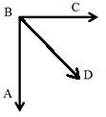Draw a one-step conclusion given:
6. is the angle bisector
7. is a right angle
8. (a) and (b)
9. (a) and (c)

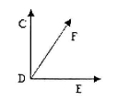

1. Draw a one-step conclusion given:
2. is a right angle
3. is a right angle
4. is a right angle
5. (a) and (b)
6. (a) and (c)
7. Draw a one-step conclusion given: ,
8. 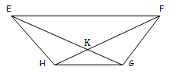
9. None of the above

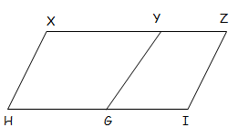

1. Draw a one-step conclusion given:
3. (a) and (b)
4. (b) and (c)
5. Which construction are the steps below for?
6. Draw a point *C* and a ray from that point (not on the original angle).
7. On the original angle, place the compass center at its vertex and draw an arc that passes through both sides.
8. **Without changing the radius**, construct that same arc using *C* as the center. Label the intersection of this arc and the new ray *D*.
9. On the original angle, *measure* the distance between the intersections of the arc with the sides.
10. Without changing the radius, draw an arc with the center at *D*.
11. Draw a ray from *C* to the intersection of the two arcs.
12. Constructing the perpendicular bisector of a segment
13. Constructing the copy of an angle
14. Constructing the copy of a segment
15. Constructing a line parallel to a segment
16. Which construction are the steps below for?
17. From the vertex of an angle, construct an arc that passes through both rays.
18. Using the intersection on one ray of the angle, draw an arc inside the angle.
19. **Without changing the radius,** draw this same arc with the center at the intersection on the other ray of the angle.
20. Use a straightedge to draw a ray from the angle’s vertex to the intersection of these two arcs.
21. Constructing the perpendicular bisector of a segment
22. Constructing the copy of an angle
23. Constructing the bisector of an angle
24. Constructing a line parallel to a segment
25. Which construction are the steps below for?
26. Mark a point not on the original line segment.
27. “Measure” the original segment with the compass.
28. **Without changing the radius**, place the center on *C* and draw an arc.
29. Use a straight edge to draw a segment from your new point to a point on the arc.
30. Constructing the perpendicular bisector of a segment
31. Constructing the copy of an angle
32. Constructing the copy of a segment
33. Constructing a line parallel to a segment
34. Which construction are the steps below for?
35. Center the compass on one endpoint and draw a large arc with a radius that is more than half of the given segment.
36. **Without changing the radius**, center the compass at the other endpoint and draw the same size arc.
37. Use a straightedge to draw a line connecting the two arc intersections.
38. Constructing the perpendicular bisector of a segment
39. Constructing the copy of an angle
40. Constructing the copy of a segment
41. Constructing a line parallel to a segment
42. When constructing parallel lines, what angle pair relationship is used?
43. What construction skill is used when constructing an equilateral triangle? How about a hexagon?
44. What two construction skills are used when constructing a square?
45. Which construction are the steps below for?
46. Draw a line segment and a point not on the line.
47. Place the center of the compass at the point then construct an arc that intersects the line segment in two places.
48. Place the center at one of the intersection points of the arc and the segment; construct an arc with a radius larger than half the distance between the intersection points on the segment.
49. Place the center at the other intersection point and construct another arc with the same radius.
50. Connect the two points where the arcs intersect.
51. Constructing the perpendicular bisector
52. Constructing a perpendicular through a point on a line segment
53. Constructing a perpendicular through a point not on a line segment
54. Constructing a parallel line to a segment
55. What construction is shown below? **16.** According to the construction shown,

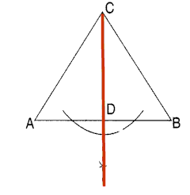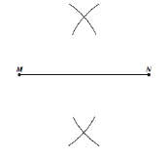 what is .

**17.** When constructing a line parallel to a given line, you will be

a) Copying a segment

b) Copying an angle

c) Bisecting a segment

d) Constructing a perpendicular

**18.**  is copied from If and , what is the length of ?

**19.**  is copied from , If , and . Find the

measure of .

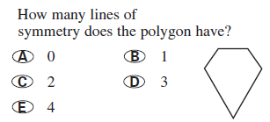 **20.**

**21.** a) All rectangles have exactly two lines of symmetry. True or False

b) A regular *n*-gonhas *n* lines of symmetry. True or False

c) Parallelograms have rotational and reflectional symmetry. True or False

d) All equilateral triangles have 60o rotational symmetry. True or False

e) A circle has no lines of symmetry True or False

**22.** Decide if the following figures have reflectional, rotational, both, or neither type of symmetry. If

rotational, describe the rotation that maps the figure onto itself. If reflectional, tell how many

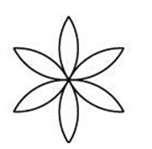 lines of symmetry it has.

1. 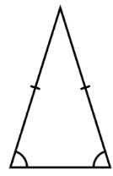 b) c)

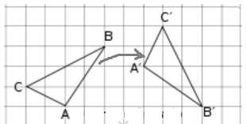 **23.** Does the transformation to the right represent rigid motion? Yes or no

If yes, what is preserved? _______________________ and ________________________________

If no, why not? _____________________________________________________________________________

 **24.**  is mapped onto by . where *a* and *b* are positive numbers.

1. , Solve for x.

**b)** If , , and , find .

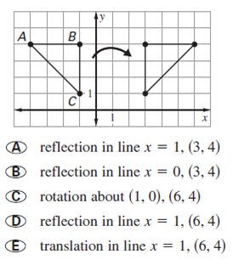 **25.** Name the type of transformation and the **26.** Describe the transformation using a

coordinates corresponding to A’. mapping function and verbal description.

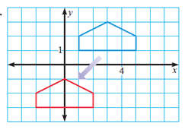

**27.** Using the diagram from question 25: What is the relationship between and ?

What is true about and the line of reflection?

**28.** Find the coordinates of each image point after the given transformation(s).

1. *D*(-5,-9) rotated 180° then reflected in
2. *F*(-3, -6) translated by
3. *A*(5, -1) reflected in the *x*-axis
4. *D*(-2,-7) rotated 90°CW

**29.** Name all isometric transformations.

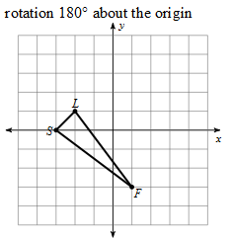

**30.** What are the image’s vertices after the following transformation?

1. S’ (-3, 0) L’ (-2, -1) F’ (1, -3)
2. S’ (3, 0) L’ (2, 1) F’ (-1, -3)
3. S’ (3, 0) L’ (2, -1) F’ (-1, 3)
4. S’ (0, 3) L’ (-1, 2) F’ (3, -1)

**31.** If *A*(3, -2) is reflected in the line *x* = 3, the coordinates of A’ are _________.

a) (0, -2) b) (3, -2) c) (3, 1) d) (-3, 2) e) (0,1)

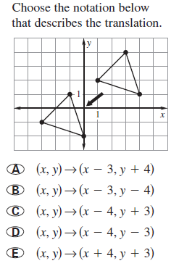**32. 33.** Graph the figure with vertices (1, 1), (-3, 5), (-5, 3),

and (-1, -1). Draw the rotation image for a

rotation of 90o counterclockwise about the origin.

*x*

*y*

**34.** Perform the following transformation and give the new vertices.

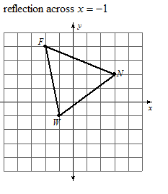

F' ( )

N' ( )

W' ( )

**35.** . Name the corresponding congruent sides and the corresponding congruent

angles of these two triangles.

1. Given: and . What other piece of information is needed to show by ASA Congruence Postulate? *DRAW A PICTURE
3. 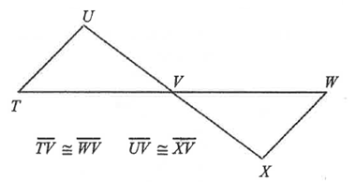 Refer to the figure shown. Which of the following statements is true?

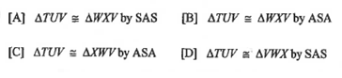

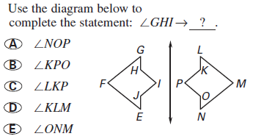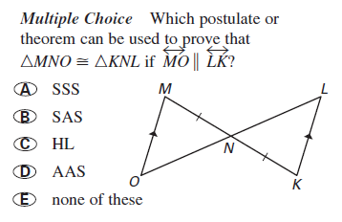

**38. 39.**

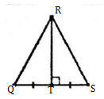 **40.** Refer to the figure below.

Why is ?

1. ASA b) SSA c) SAS d) AAS

Is ? If, so why? ___________________________

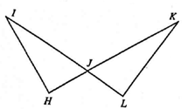 **41.** State two postulates or theorems that can **42.** Name the congruent triangles and tell which   
 be used to conclude that . method proves the triangles congruent.

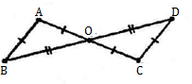**Given**:

_____________ ____________

1. Give an example of each angle pair relationship.
2. 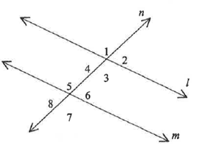Alternate Interior Angles _____________
3. Alternate Exterior Angles _____________
4. Corresponding Angles _____________
5. Vertical Angles _________________
6. Supplementary _________________
7. 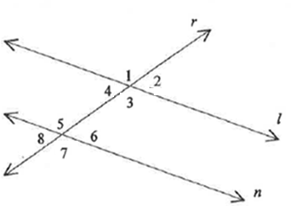In the figure, and is a transversal. Which of the following is not necessarily true?

a)

b)

c)

d) 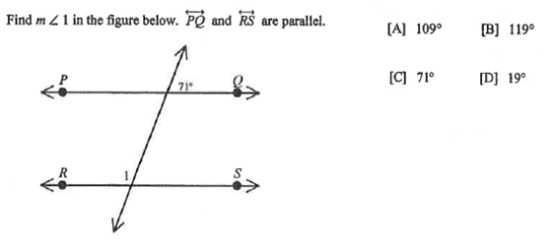



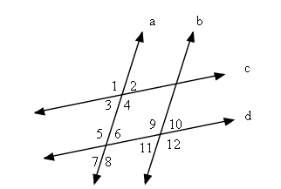**46.** Tell which lines, if any, are parallel based on the given information.

a)

d)

1. Draw a conclusion and give a reason for each piece of information.
   1. **b) c)**

Conclusion: Conclusion: Conclusion:

Reason: Reason: Reason:

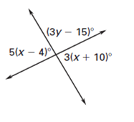

**48.** Solve for *x* and *y*.

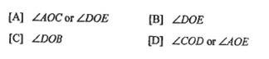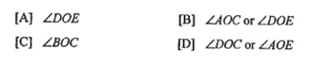 **49.** In fig. 1**, name** an angle comp. to  **50.** In fig. 1, **name** an anglesup. to

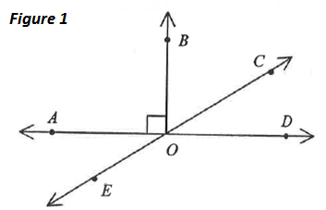

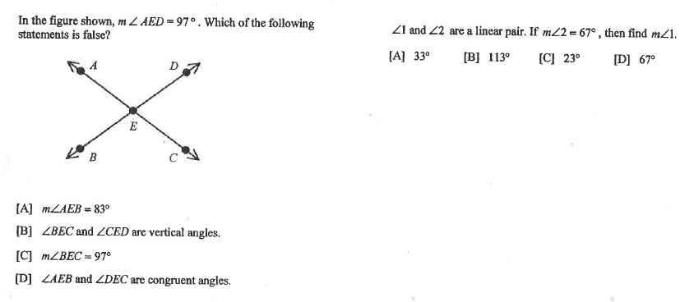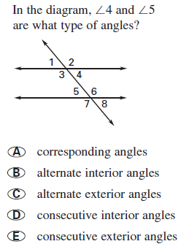

**51. 52.**

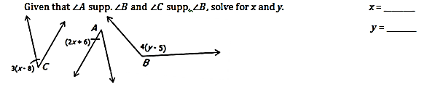 **53.**

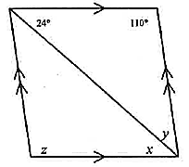 **54.**  and are a linear pair. If , then **55.** Find the value of the variables in the

find the . parallelogram.

a) 33

b) 113

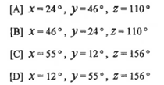 c) 23

d) 67

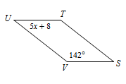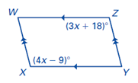**56.** The following figures below are parallelograms. Find the values of the variables.

a) b)

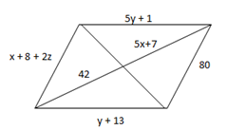

c)

1. 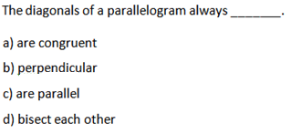In parallelogram HIJK, What is  **58.**

the value of x?

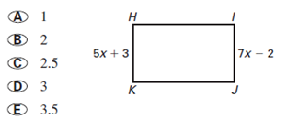

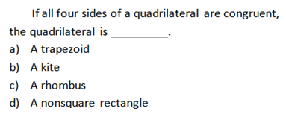**59.** Which statement is true?  **60.**

a) All quadrilaterals are squares.

b) All rectangles are quadrilaterals.

c) All rectangles are squares.

d) All quadrilaterals are rectangles.

**61.** Choose the statement that is NOT ALWAYS true.  **62.** T or F. Some parallelograms are trapezoids.

For a rhombus __________.

a) Each diagonal bisects a pair of opp. angles **63.** T or F. A square is a rhombus.

b) All four sides are congruent

c) The diagonals are congruent **64.** Name all quadrilaterals that have at least

d) The diagonals are perpendicular one pair of parallel sides.

**65.** Find the measure of the interior angles. (Drawing not to scale).

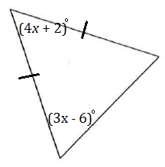

1. What is the measure of each base angle of an isosceles triangle if its vertex angle measures 36

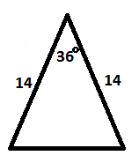 and its 2 congruent sides measure 14 units?

1. 54 b) 144

1. 72 d) 36
2. In , if and , then _______.
3. 39 b)  *m* c) 102 d) 141
4. 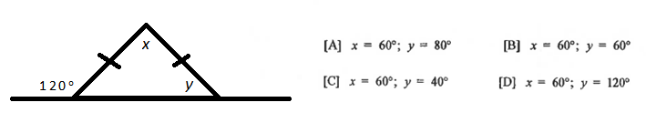 Find the value of *x* and *y*.
5. 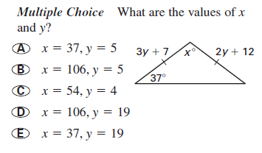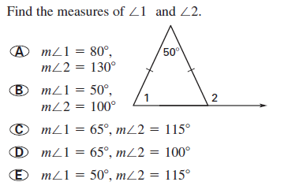 **70.**

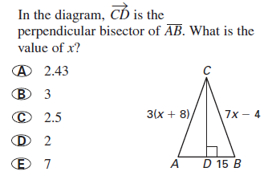

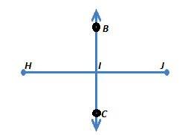 **71. 72.** Given: is bisector of .

Which of the following are true?

Check all that apply.

[ ] is the midpoint of   
 [ ]

[ ] is the midpoint of

[ ]

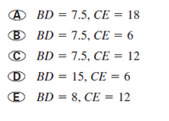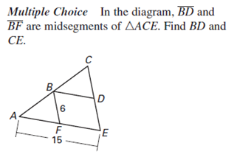 **73.**

1. Solve for *x* given that and . Assume *B* is the midpoint of and *D* is

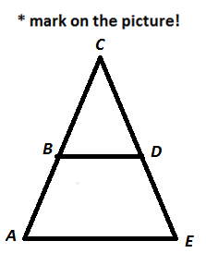 the midpoint of .

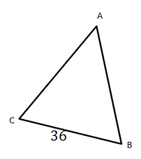 **75.** Draw in the midsegment where E is the midpoint of and F is the midpoint of

1. What is the length of this midsegment? __________
2. Circle all statements that are true.
3. 2. 3.

4. 5. 6.

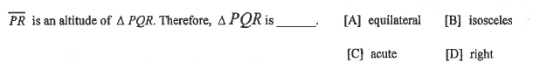

**76.**

**77.** The concurrency of the medians is called the _______________________.

* For a right triangle, the point is located ______________________________.
* For an acute triangle, the point is located ____________________________.
* For an obtuse triangle, the point is located___________________________.

**78.**  The concurrency of the altitudes is called the _______________________.

* For a right triangle, the point is located _____________________________.
* For an acute triangle, the point is located ___________________________.
* For an obtuse triangle, the point is located__________________________.

**79.** The concurrency of the perpendicular bisectors is called the __________________________.

* For a right triangle, the point is located ___________________________.
* For an acute triangle, the point is located __________________________.
* For an obtuse triangle, the point is located_________________________.

**80.** The concurrency of the angle bisectors is called the _____________________________.

* For a right triangle, the point is located ____________________________.
* For an acute triangle, the point is located ___________________________.
* For an obtuse triangle, the point is located__________________________.

**81.** What is the first step in constructing a circle **inscribed** in a triangle?

a) The measurement of each side

b) The midsegments of the triangle

c) The angle bisectors of each angle

d) The perpendicular bisectors of each side

**82.** What is the first step in constructing a circle **circumscribed** about a triangle?

a) The measurement of each side

b) The midsegments of the triangle

c) The angle bisectors of each angle

d) The perpendicular bisectors of each side

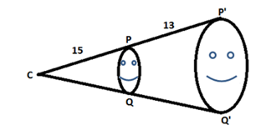 **83.** The scale factor for the dilation shown below is _____________.



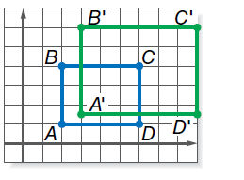

**84.** For the figure, find the center of dilation and give the scale factor.

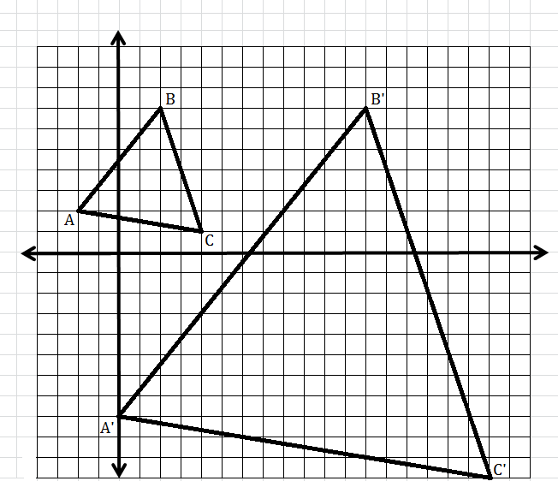

**85.** Find the center of dilation.

a) (6, 2)

b) (-3, 7)

c) (-4, 7)

d) (4, -7)

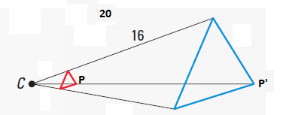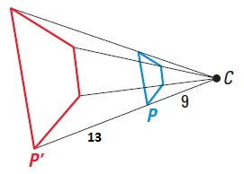 **86.** Identify the dilation as a reduction or an enlargement, then give the scale factor.

1. b)

**87.** Decide if the described sequences of transformations will produce congruent figures, similar figures,

or neither.

1. (x, y) 🡪 (-x, -y) 🡪 (x, y) b) (x, y) 🡪(x – 7, y + 5) 🡪(5x, )

**88.** If SIMILAR, then the corresponding sides must be _____.

1. Similar b) Parallel c) congruent d) proportional

**89.** If two polygons are SIMILAR, then the corresponding angles must be _____.

1. supplementary b) complementary c) congruent d) linear pairs

**90.** The perimeter of is 65. = 15, and . What is the perimeter of ?

1. 26 b) 12.2 c) 2.8 d) 52

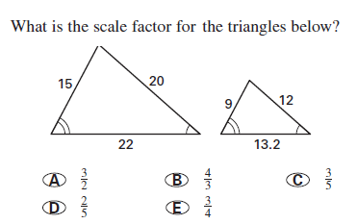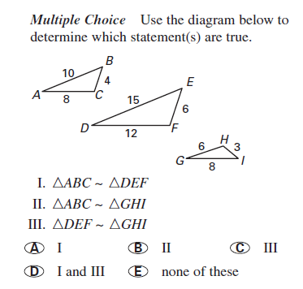

**91. 92.**

**93.** Which value of *AB* would make  **94.** Given that . Find the length of .

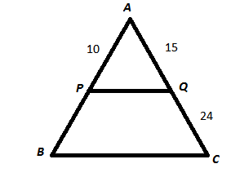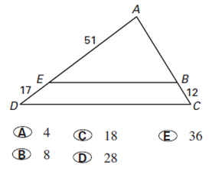

a) 26 b) 22 c) 23 d) 28

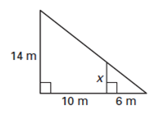**95.** Find the length of *x* in the diagram. **96.** Solve for all variables.

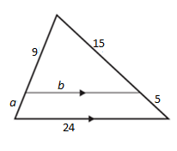

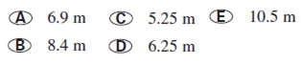

**97.** Tell whether the polygons are *always*, *sometimes*, or *never* similar.

a) __________________ two equilateral triangles e) __________________ two regular hexagons

b) __________________ two right triangles f) __________________ a right and an acute triangle

c) __________________ two squares g) _________________ an isosceles and a right

d) __________________ two rectangles

**Proofs for Finals Review:**

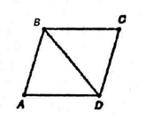For #1 – 5 below, give the rigid motion that maps the congruent triangles to each other.

1. 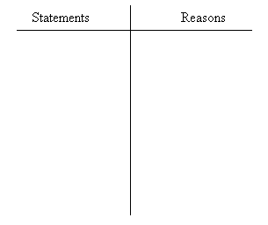

Given: , bisects 

Prove: ∆*ABD* ≌ ∆*CBD*

1) ___________________________________________________

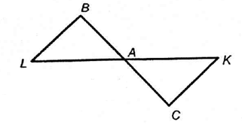

Given: *A* is the mdpt. of and

Prove: ∆*BLA*≌ ∆*CKA*

2) ___________________________________________________



1. 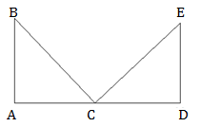

Given: ,

∠B ≌ ∠E, C is mdpt. of

Prove: ∆ABC ≌ ∆DEC

3) ___________________________________________________

1. 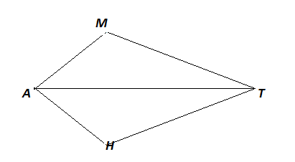

Given: bisects ∠*MAH* and ∠*MTH*

Prove:

4) ___________________________________________________

1. 

Given: ,

Prove:

5) ___________________________________________________

1.  Given that , prove that alternate exterior angles are congruent () by the **corresponding angle postulate**.



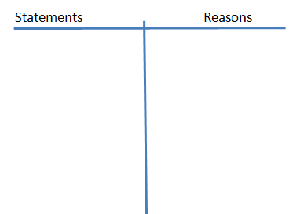



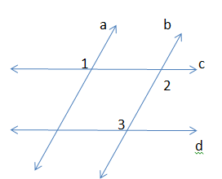

1. 

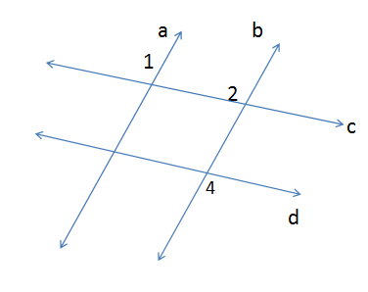

1.  Given: ABDC is a parallelogram

Prove: opposite angles are congruent

**Use only the definition of parallelogram**

(Hint: draw a diagonal!!)

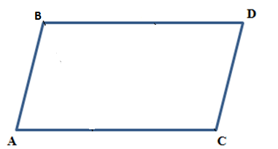



1. Given:

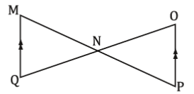Prove: